**KIT LABEL (this is also a WO label)**

The KITS LABELS Should be printed from the GSS menu as a customized menu item. Label is 1.5 X 3.5”

**Data field**

**\*The first label**

**Part Number:**

Router Number

**Revision Part:**

Router Revision

**Description Part:**

Description part number

**QTY:**

Work Order quantity

**UOM:**

Inventory part number Unit of Measure

**Due Date:**

Work order due date

**Work Order (WO#)**

Work Order Number

**Master work order (MWO#)**

Master work order number

Exploted Router parts label after the first label (Router Number)

**Part Number:**

Inventory purchase part number

**Revision Part:**

Revision of the part number

**Description Part:**

Description part number

**Manufacturing Name:**

The manufacturer name of the part number should came from GSS reference part inventory.

**Quantity Pieces Received:**

Quantity pieces received.

**Manufacturing Model:**

The manufacturer model part number should came from GSS reference part inventory.

**Bin Number:**

Should be come from GSS part number inventory

**UOM:**

Inventory part number Unit of Measure

**Work Order (WO#)**

Work Order Number

**Master work order (MWO#)**

Master work order number

NOTE:

At The end we print another copy of the router label to know the kit label is done. In case is a BOM need to print the one label of the parent beginning and other copy at the explosion end (on label for bin one for the bag ).

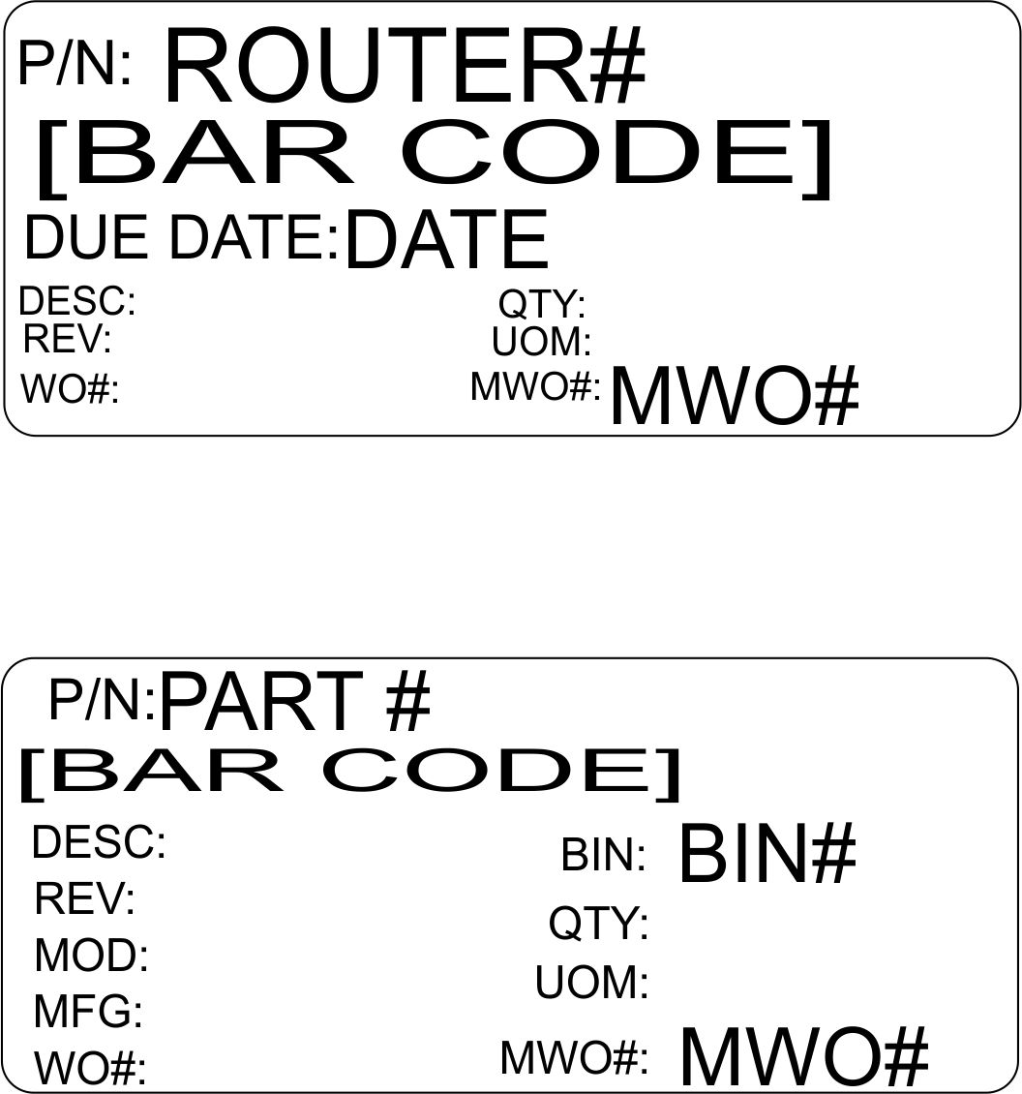

To flag all the parts that need to have a label printed on the kit we are going to the “Excp” field. Input a Y to indicates that a label is needed for this part and a N when not.

Inventory>inventory> parts options

